WORKSHEET C

Write short notes next to each picture. Use the correct terms to describe and explain what is happening.

1. Black Van.
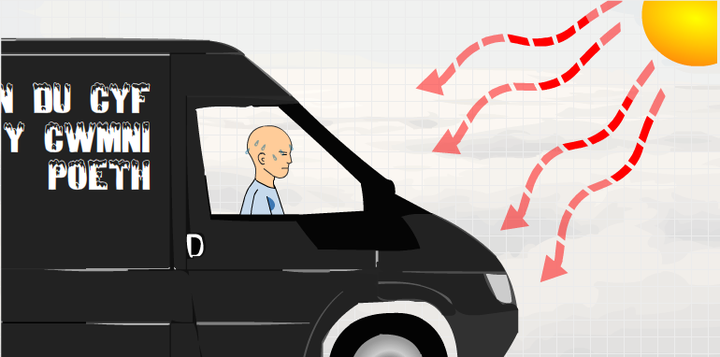
2. White Van.
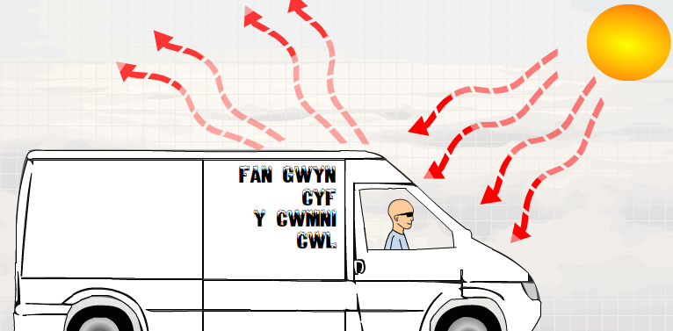
3. Black saucepan.
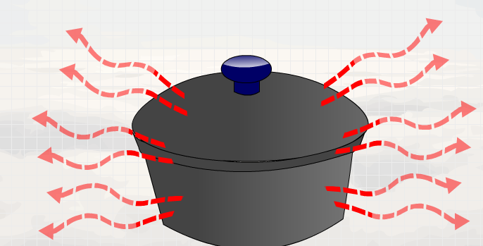
4. Saucepan with foil.
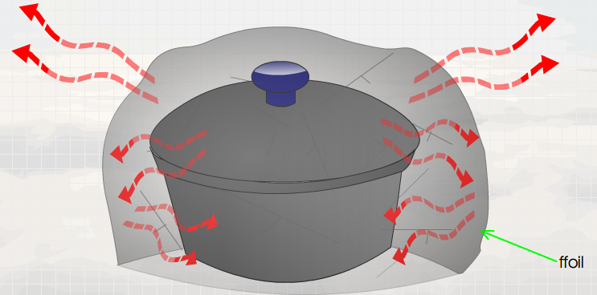
foil

